SIMATS ENGINEERING (SAVEETHA SCHOOL OF ENGINEERING)
Department of Computer Science and Engineering

ASSESSMENT TOOL 1 – Coding Challenge Task
Course Code: | CSA06 | Course Title: | Design and Analysis of Algorithms
CO Assessed: | CO4: Articulation (BL4, BL5) | Assessment: | Assessment Tool 1 – Coding Challenge Task
Weightage: | 40% of CIA | Total Marks: | 100
CO4 Statement: | Solve optimization problems using dynamic programming and greedy strategies.
Student Name: | Naveen Kumar S | Reg. No.: | 192421030
Section / Batch: | B Tech IT | Date: | 22.08.2026

Instructions

to

Students

•

Answer

the

following

question.

Total

Marks:

100.

•

Carefully

analyze

the

given

questions.

•

Write

clear

code

for

the

given

problem.

•

Analyze

the

Time

complexity

and

Space

complexity

of

your

code

using

dynamic

programming

and

greedy

strategies

Question Type | Focus Area | Questions
Coding Challenge Task | Focus on Code and analyze optimization problems using dynamic programming and greedy strategies | Q1

SECTION A – Coding Challenge Task Code of Conduct
I

Naveen

Kumar

S

-

192421030

(
Name

/

Reg

No)

certify

that

this

submission

is

my

original

work

and

that

I

have

adh
ered

to

the

guidelines

specified

for

this

assessment.

I

understand

that

any

violation

of

academic

integrity

rules

will

result

in

disciplinary

action.

Signature

of

the

Student:

Naveen

Kumar

S

RUBRICS FOR CALCULATION

Coding Challenge Task
Criteria | Weightage | Level 4 (Exemplary) | Level 3 (Proficient) | Level 2 (Developing) | Level 1 (Beginning)
Problem Understanding | 20% | Clearly understands  problem  constraints, edge cases, and  competitive requirements | Understands  problem with  minor gaps in  constraints | Partial understanding; misses key constraints | Misinterprets problem or constraints
Algorithm | 25% | Selects optimal algorithm with  best time and space  complexity for  competitive  constraints | Uses efficient algorithm with  minor scope for  improvement | Uses basic/inefficient approach | No clear algorithmic  approach
Code Implementation | 20% | Writes correct, efficient, and  clean code that passes all constraints | Code works with minor errors or inefficiencies | Partially correct code; fails for some cases | Code does not execute or gives incorrect results
Competitive  Performance | 20% | Solves problem within time limits and  handles large inputs effectively | Solves within acceptable time with minor delays | Struggles with time limits or larger inputs | Unable to solve within time  constraints
Test Case  Handling | 15% | Handles all test cases including edge and hidden cases | Handles most test cases | Misses important edge cases | Fails on multiple test cases

Marks Evaluation:
Criteria | Wt. | Level 4 –  Exemplary | Level 3 –  Proficien  t | Level 2 –  Developing | Level 1 –  Beginning
Problem Understanding | 20%
Algorithm | 25%
Code Implementation | 20%
Competitive Performance | 20%
Test Case Handling | 15%
Total Marks (100):

Faculty In-charge | Course Coordinator | Head of Department
Name: | Name: | Name:
Signature: _______________ | Signature: _______________ | Signature: _______________
Date: ___________________ | Date: ___________________ | Date: ___________________

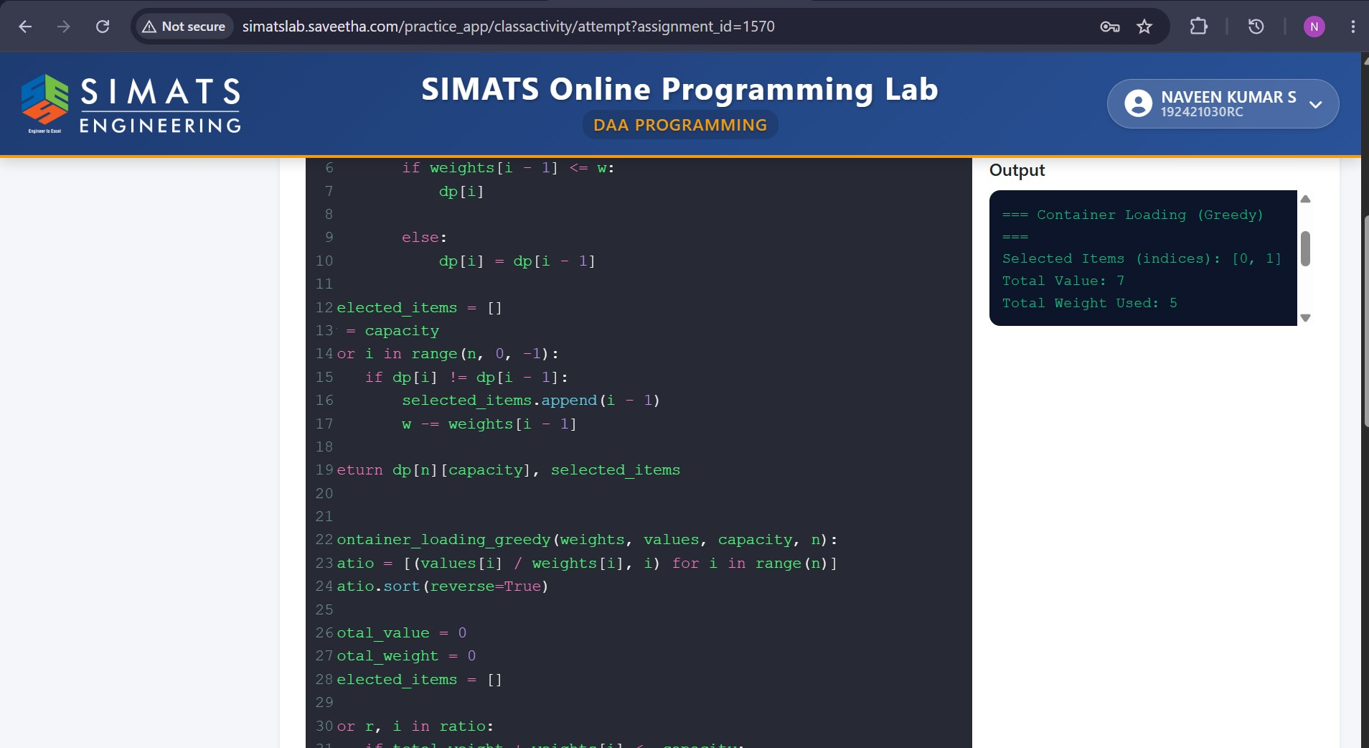
Algorithm And Explanation :

- 0/1 Knapsack using Dynamic Programming (DP)
- Container Loading using a Greedy method
Then compare their results, explain why greedy may fail for discrete optimization, analyze complexity, and discuss logistics applications.
1. 0/1 Knapsack — Dynamic Programming
Problem idea
Given:
- n items
- Each item has a weight w[i]
- Each item has a value/profit v[i]
- Knapsack capacity = W
The goal is to select items so that:
- Total weight ≤ capacity
- Total value is maximum
- Each item can be selected at most once
Algorithm
Algorithm: 0/1 Knapsack using Dynamic Programming

Input:
n = number of items
w[1...n] = weights
v[1...n] = values
W = knapsack capacity

Create DP table K[n+1][W+1]

For i = 0 to n:
For j = 0 to W:

If i == 0 or j == 0:
K[i][j] = 0

Else if w[i] <= j:
K[i][j] = max(
v[i] + K[i-1][j-w[i]],
K[i-1][j]
)

Else:
K[i][j] = K[i-1][j]

Maximum value = K[n][W]

To find selected items:
Start from K[n][W]
Move backwards:
If K[i][j] != K[i-1][j]:
select item i
j = j - w[i]
i = i - 1

Output:
Selected items
Total weight
Maximum value
Explanation
For every item, we have two choices:
- Include the item
- Do not include the item
The recurrence is:
if the item fits.
If the item does not fit:
The DP table stores the best value possible using the first i items with capacity j.

2. Container Loading — Greedy Algorithm
For container loading, the objective is generally to load as much useful cargo as possible within the container's capacity.
A simple greedy strategy is:
Select items in decreasing order of their value-to-weight ratio.
Calculate:
Then sort the items according to this ratio.
Algorithm
Algorithm: Container Loading using Greedy

Input:
n = number of items
w[1...n] = weights
v[1...n] = values
W = container capacity

For each item:
Calculate ratio[i] = v[i] / w[i]

Sort all items in decreasing order of ratio

current_weight = 0
total_value = 0

For each item in sorted order:

If current_weight + w[i] <= W:
Select item i
current_weight = current_weight + w[i]
total_value = total_value + v[i]

Output:
Selected items
Total weight
Total value
Utilization = (current_weight / W) × 100
Explanation
Greedy makes the locally best choice at each step.
For example, if an item has:
Item | Weight | Value | Value/Weight
A | 10 | 60 | 6.0
B | 20 | 100 | 5.0
C | 30 | 120 | 4.0
Greedy chooses A first, because it has the highest value per unit weight.
It then continues selecting the next best ratio item that fits.

3. Comparison of DP and Greedy
Feature | 0/1 Knapsack DP | Greedy Container Loading
Method | Dynamic Programming | Greedy
Decision | Considers combinations | Makes local choices
Optimal solution | Yes | Not always
Items | Cannot be divided | Usually selected as whole items
Time complexity | O(nW) | O(n log n)
Space complexity | O(nW) | O(n)
Computation | Higher | Lower
Accuracy | Optimal | May be suboptimal
Suitable for | Discrete optimization | Fast approximate decisions

4. Why Greedy Fails for 0/1 Knapsack
This is the important conceptual part.
Greedy works very well for the fractional knapsack problem, where an item can be divided.
But in 0/1 Knapsack, an item is indivisible.
Consider:
- Capacity = 50
- Item A: weight = 10, value = 60
- Item B: weight = 20, value = 100
- Item C: weight = 30, value = 120
Ratios:
- A = 6
- B = 5
- C = 4
Greedy selects:
A + B
Weight:
Value:
There is still 20 capacity, but C cannot fit.
So greedy gives:
However, DP chooses:
B + C
Weight:
Value:
Therefore:
So greedy gives 160, while the optimal DP solution gives 220.
Main reason
Greedy considers:
"Which item is best right now?"
DP considers:
"Which combination of items gives the best overall result?"
That is why greedy can fail when items are discrete/indivisible.

5. Utilization Efficiency
Container utilization can be calculated as:
For example, if:
- Container capacity = 50 kg
- Loaded weight = 50 kg
then:
If greedy loads only 30 kg:
However, 100% weight utilization does not necessarily mean the best solution. In real logistics, volume, item priority, value, fragility, delivery deadlines, and transportation constraints may also matter.

6. Computational Complexity
Dynamic Programming
The DP table has approximately:
states.
Therefore:
Time:
Space:
It can be reduced to O(W) space using a one-dimensional DP array.
Greedy
First calculate value/weight ratios:
Then sort the items:
Then scan the sorted list:
Therefore:
So greedy is generally much faster than DP when the capacity W is large.

7. Real-World Logistics Applications
These algorithms can be applied to:
- Truck loading — deciding which packages should be loaded.
- Container shipping — selecting cargo within weight/volume limits.
- Air cargo — maximizing valuable cargo while respecting aircraft weight limits.
- Warehouse operations — selecting products for shipment.
- Delivery planning — prioritizing high-value packages.
- Emergency logistics — selecting the most important supplies when vehicle capacity is limited.
- Cloud/data storage — selecting files or jobs under storage/capacity constraints.
In real systems, the problem is often more complicated than basic knapsack because there can be multiple constraints such as weight, volume, dimensions, destination, priority, and delivery time.

8. Solution Strategy Insights
The main conclusion is:
Use DP when:
- An exact optimal solution is important.
- Items are indivisible.
- The number of items and capacity are manageable.
- Missing the optimal combination has significant cost.
Use Greedy when:
- A fast solution is required.
- An approximate solution is acceptable.
- The problem has a property that guarantees greedy optimality.
- The dataset is very large.
Best practical approach
A logistics system can use a hybrid strategy:
Greedy → generate a good initial solution → DP/optimization → improve the solution
This gives a balance between speed and solution quality.
Final conclusion
0/1 Knapsack with DP guarantees the optimal combination but requires more computation. Greedy container loading is faster and simpler but can miss the optimal combination because locally attractive items can prevent better combinations later. Therefore, the choice between them depends on whether the priority is optimality or computational speed.

